**Installing SonarQube**

1. Go to official website of sonarqube and download the latest community edition
2. Extract the zip file
3. Navigate inside the sonarqube/sonarqube/bin/windows-x86-64. Check if a StartSonar.bat file is present.
4. If the StartSonar.bat file is present then copy the path of that folder
5. Open CMD as Run As Administrator
6. Type cd C:\Users\renur\Downloads\sonarqube-10.7.0.96327\sonarqube-10.7.0.96327\bin\windows-x86-64



1. Type StartSonar.bat Gives errors:
2. **New approach: Using Docker image**
3. Open DockerDesktop. And pull the sonarqube image

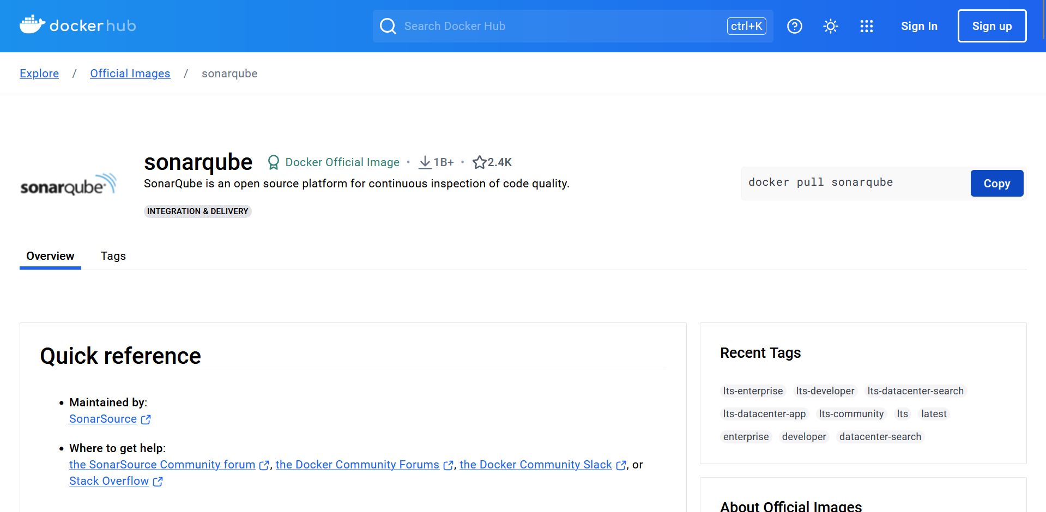

1. Pull the image

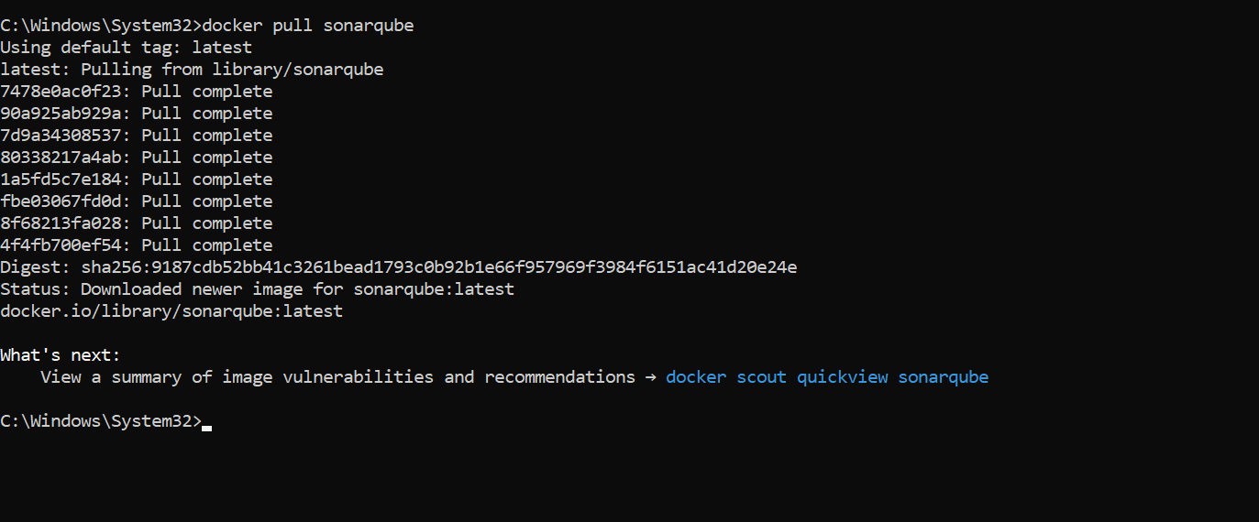

1. Run the image: docker run -d --name sonarqube -e SONAR_ES_BOOTSTRAP_CHECKS_DISABLE=true -p 9000:9000 sonarqube:latest

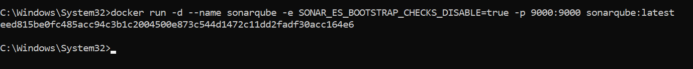



1. SonarQube will now run at localhost:9000
2. Default login = admin and password = admin

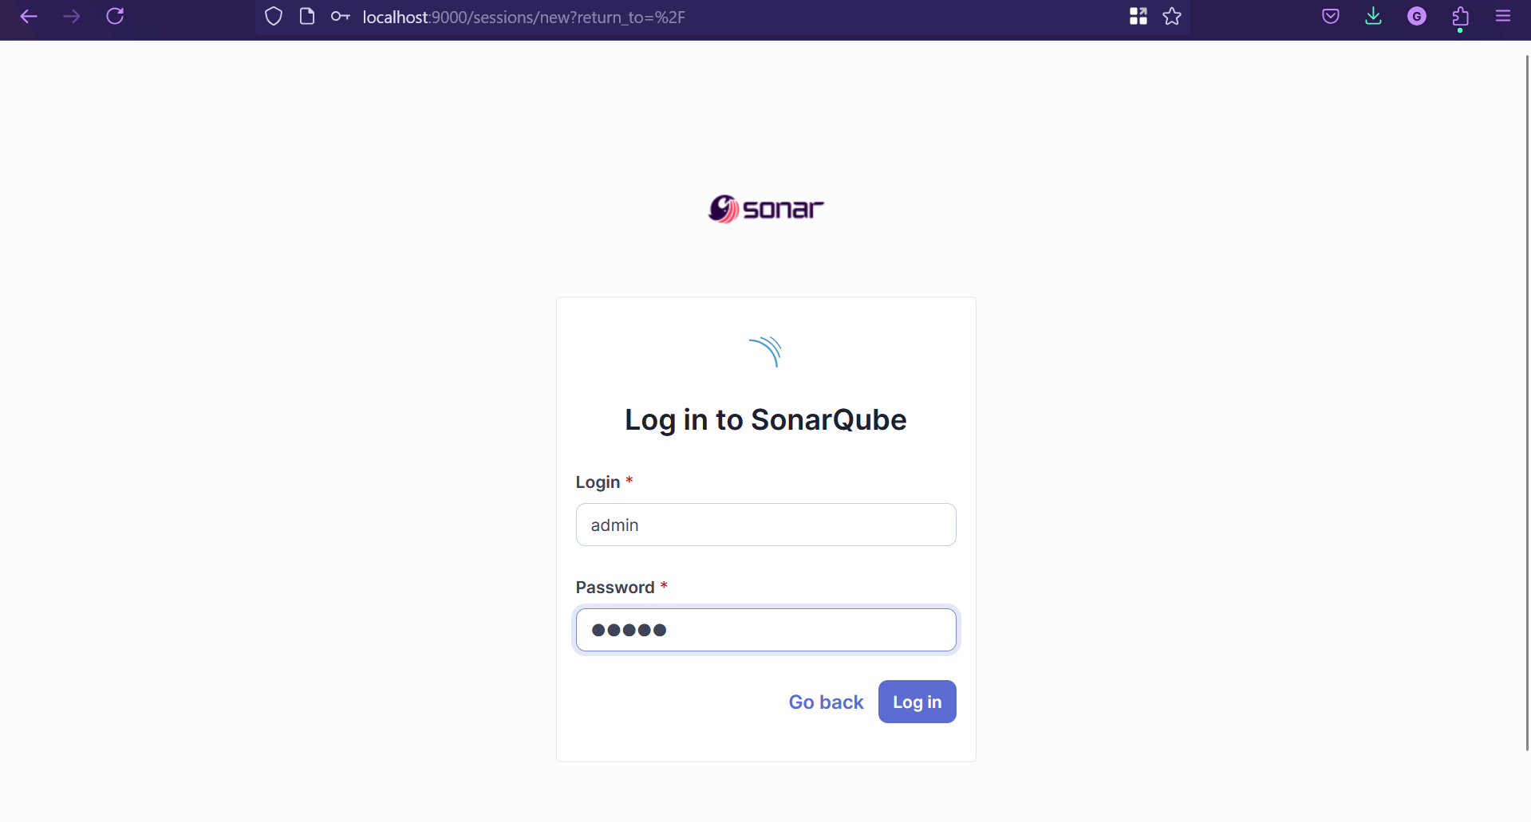

1. Update your password

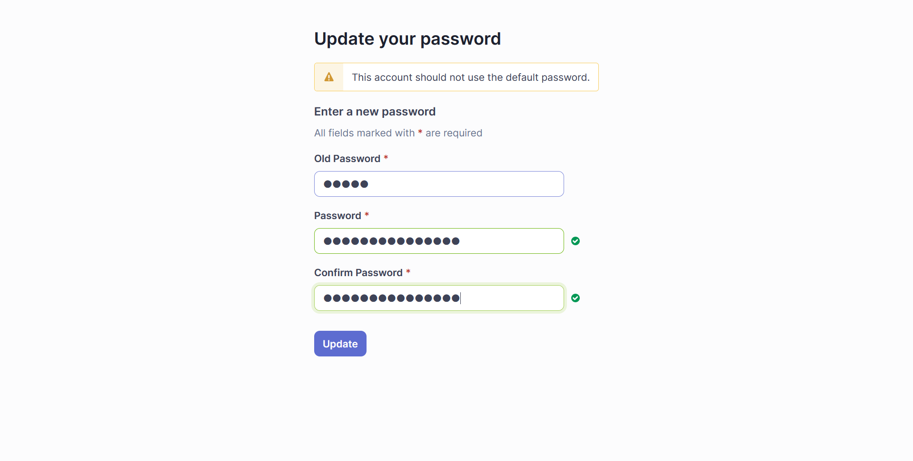

1. After logging in

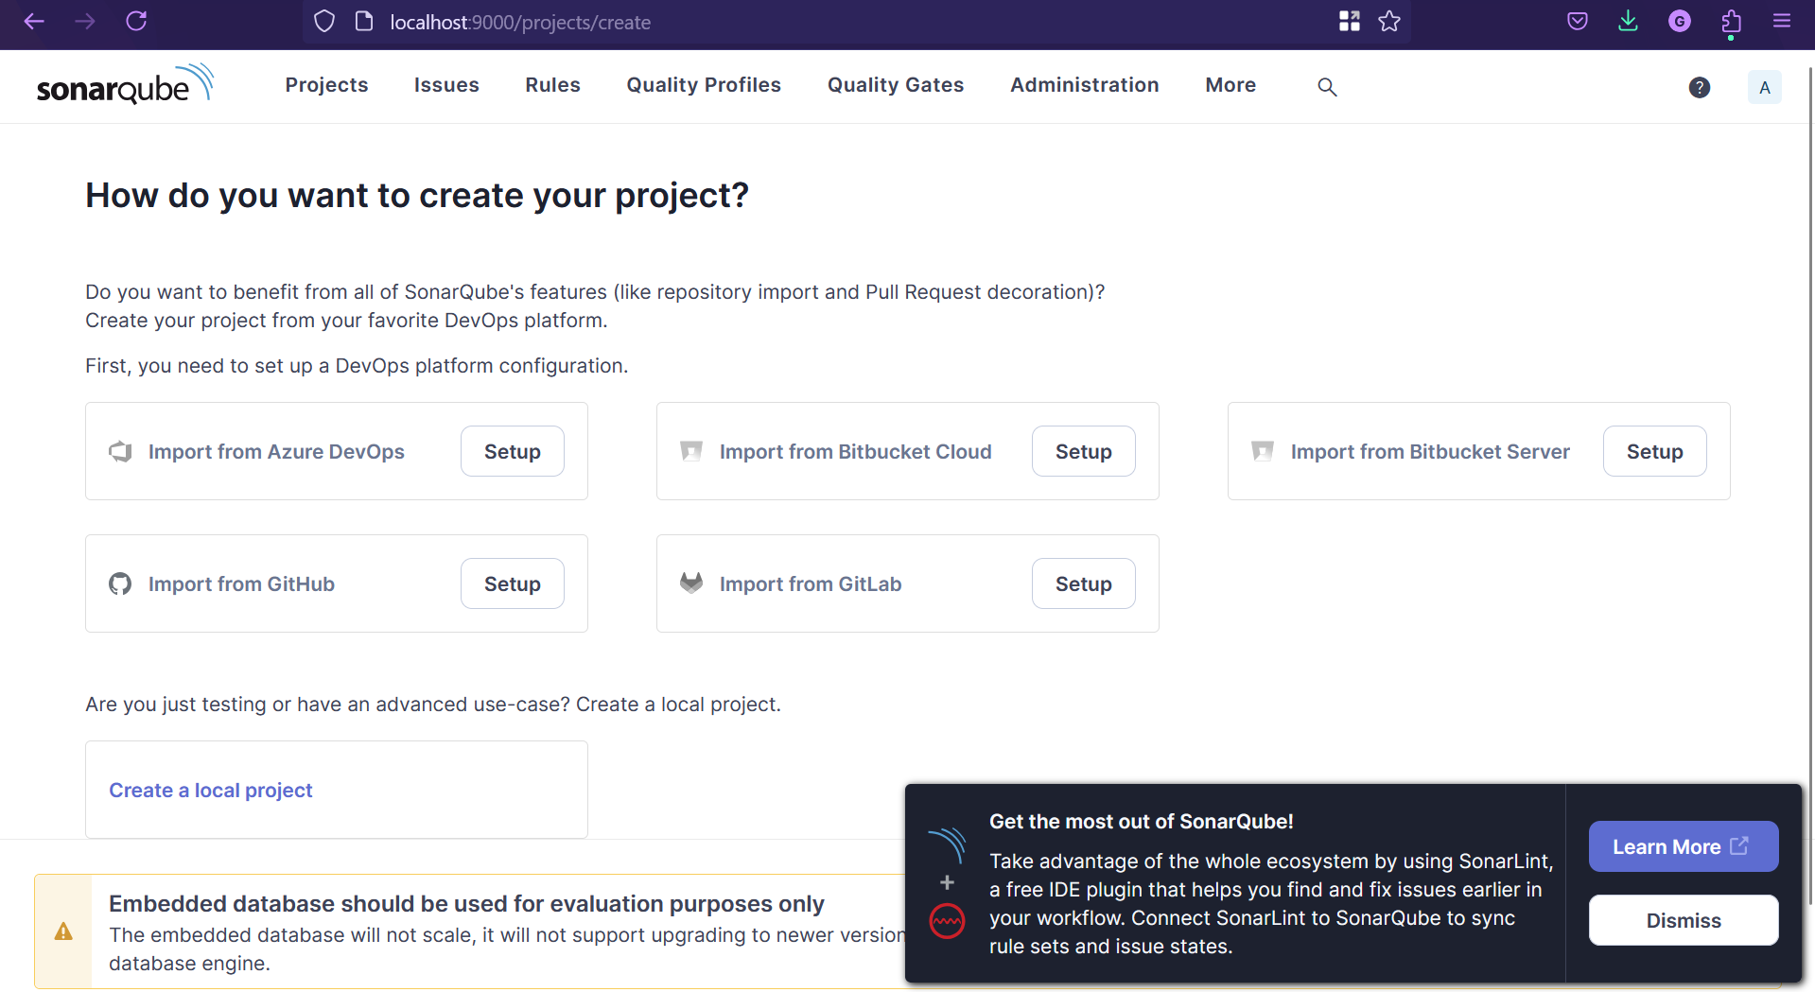

1. **Steps to integrate SonarQube with Jenkins.**
2. Start Jenkins on WSL Ubuntu: sudo systemctl start Jenkins



1. Go to localhost:8080 and give your Username and Password

1. Manage Jenkins -> Plugins

1. Avaible Plugins -> Search sonar -> Click on SonarQubeScanner -> Install

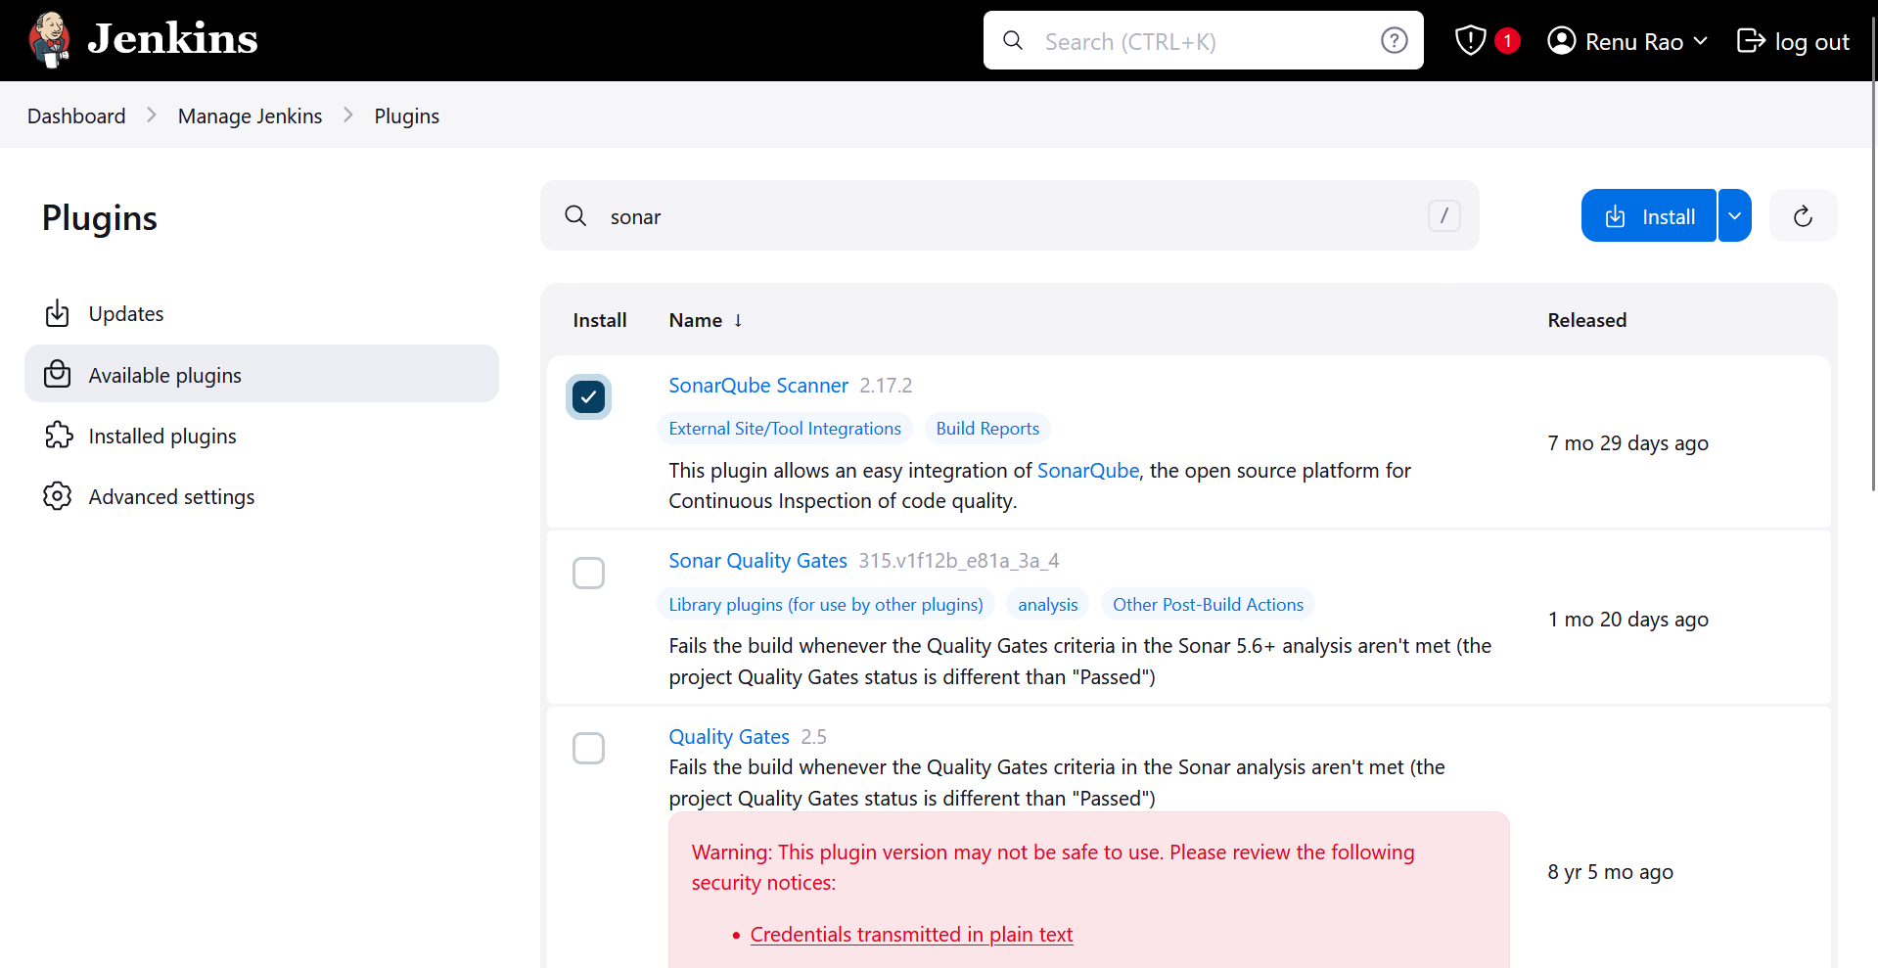

1. After installing

1. Go to localhost:9000 -> Administration -> Security

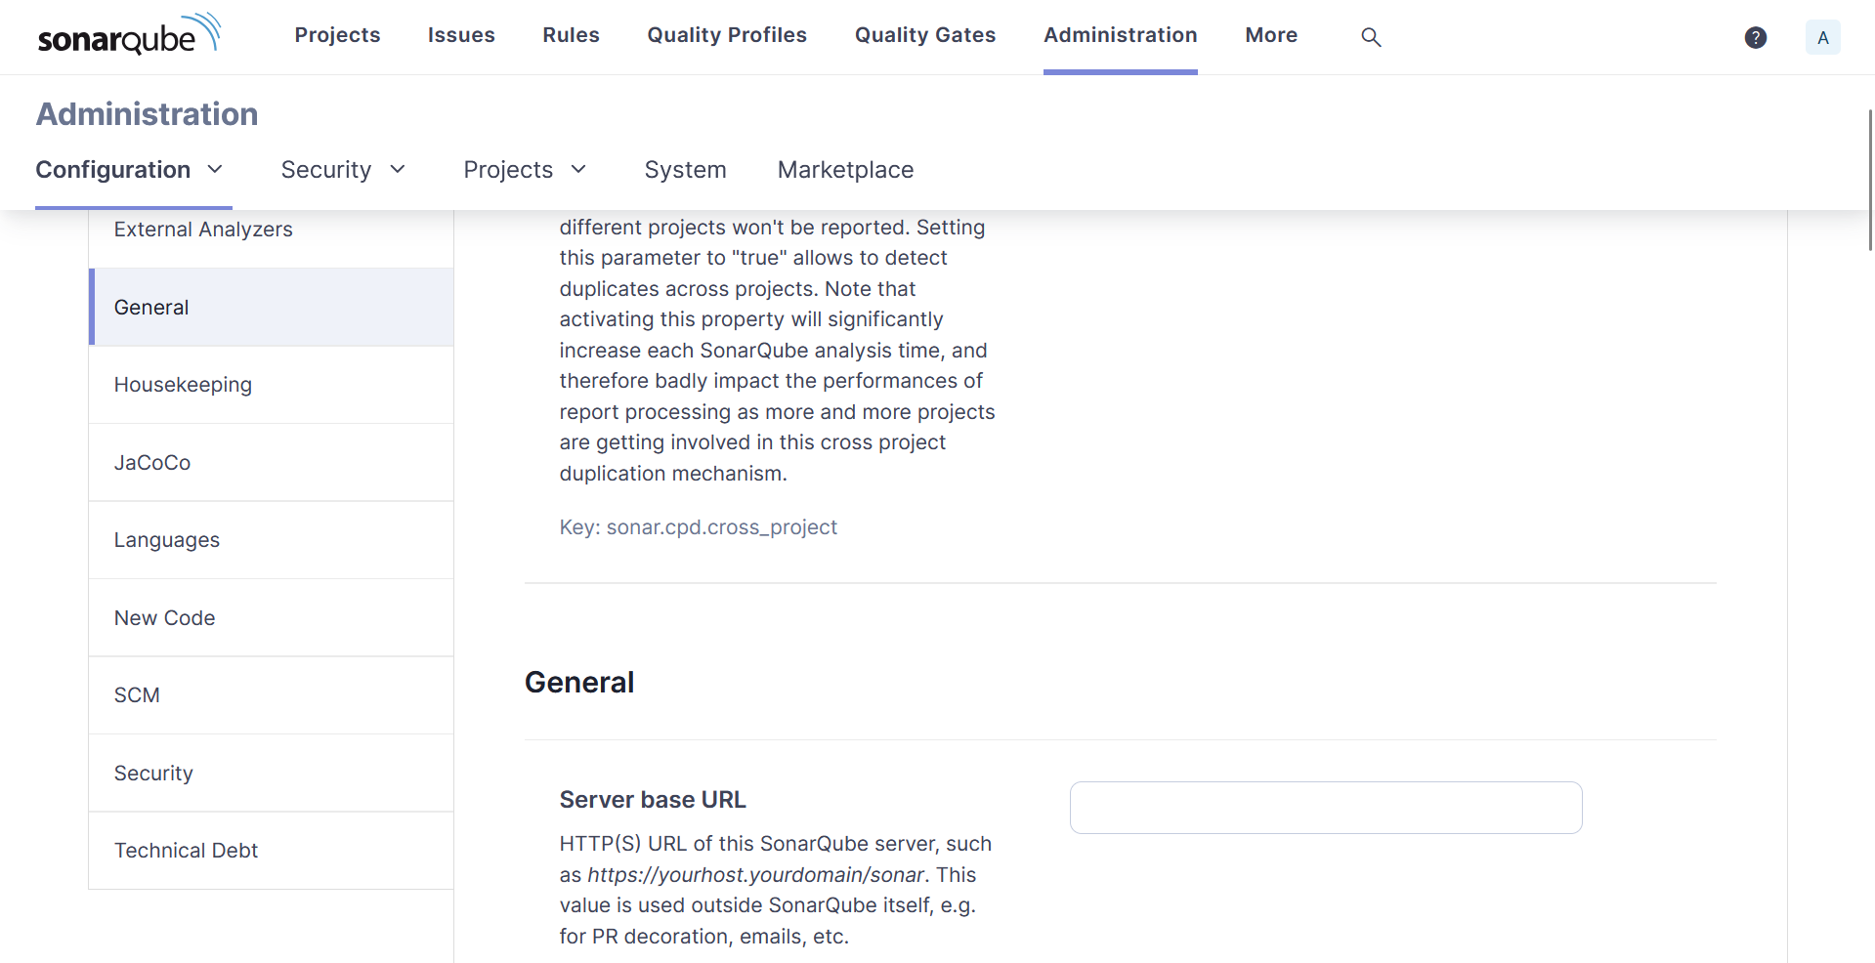

1. In Secutity dropdown -> select Users

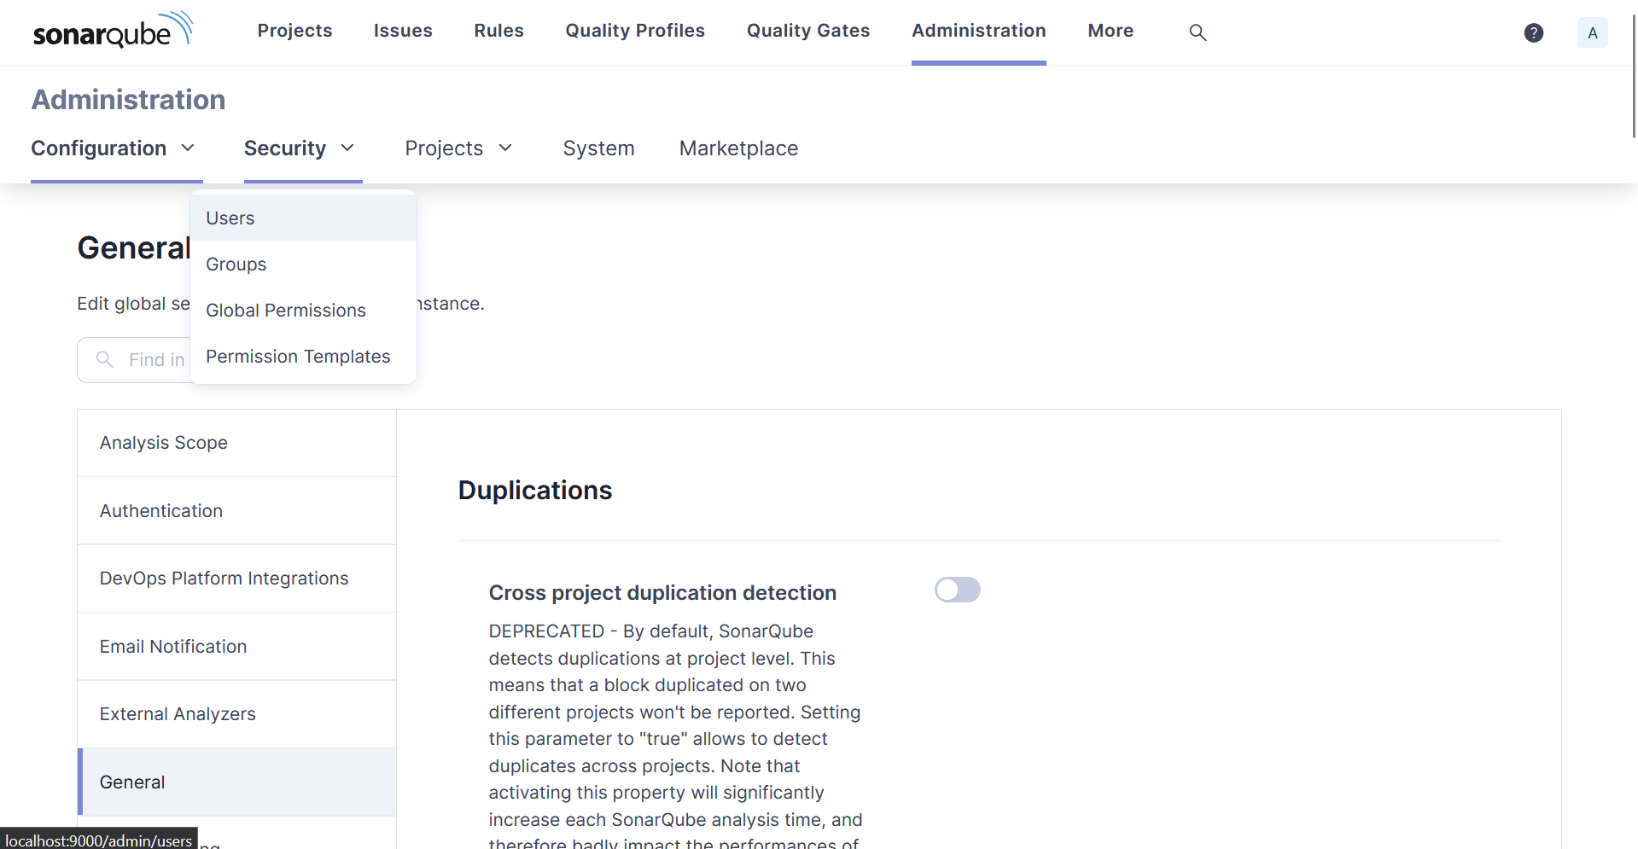

1. Click on 3 dots -> Generate token with some name

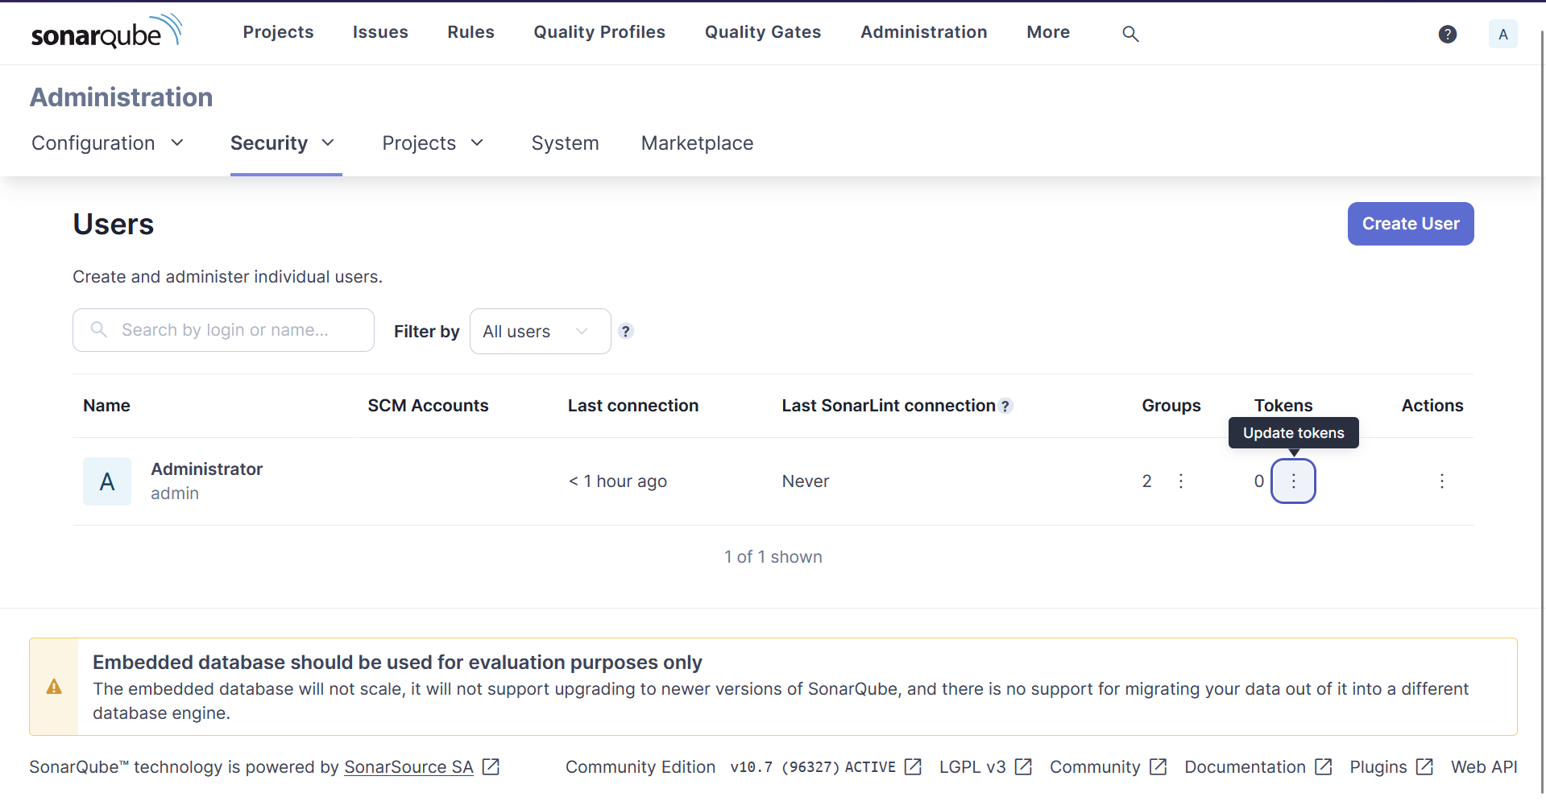

Token: squ_c5958a13840aec47ad4cd218f88a968496eec388

1. Go to localhost:8080 -> Manage Jenkins -> System -> Scroll down and click Add SonarQube

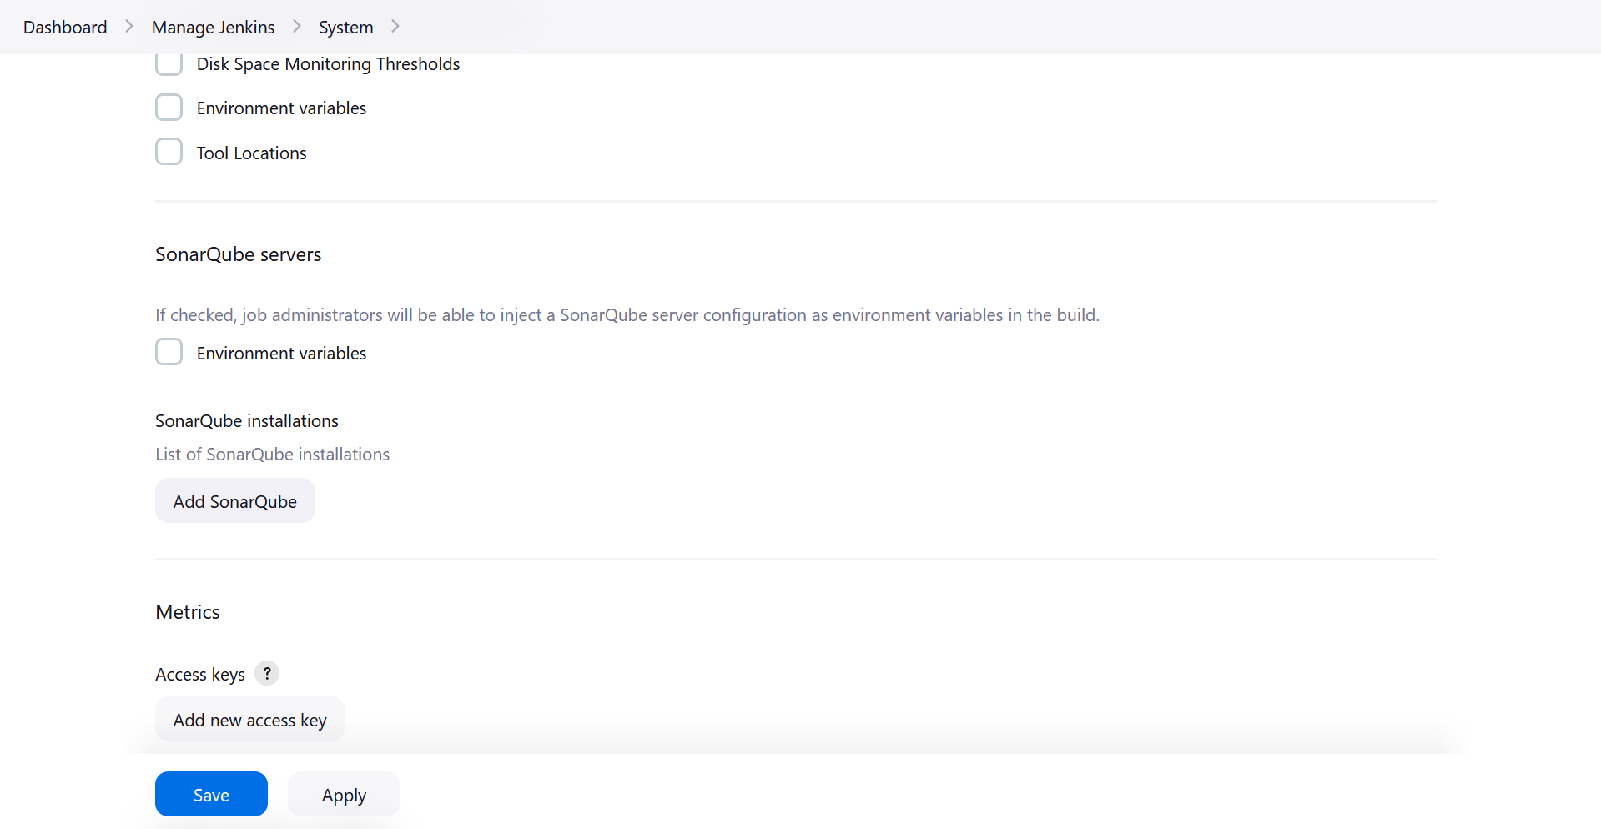

1. After click Add SonarQube

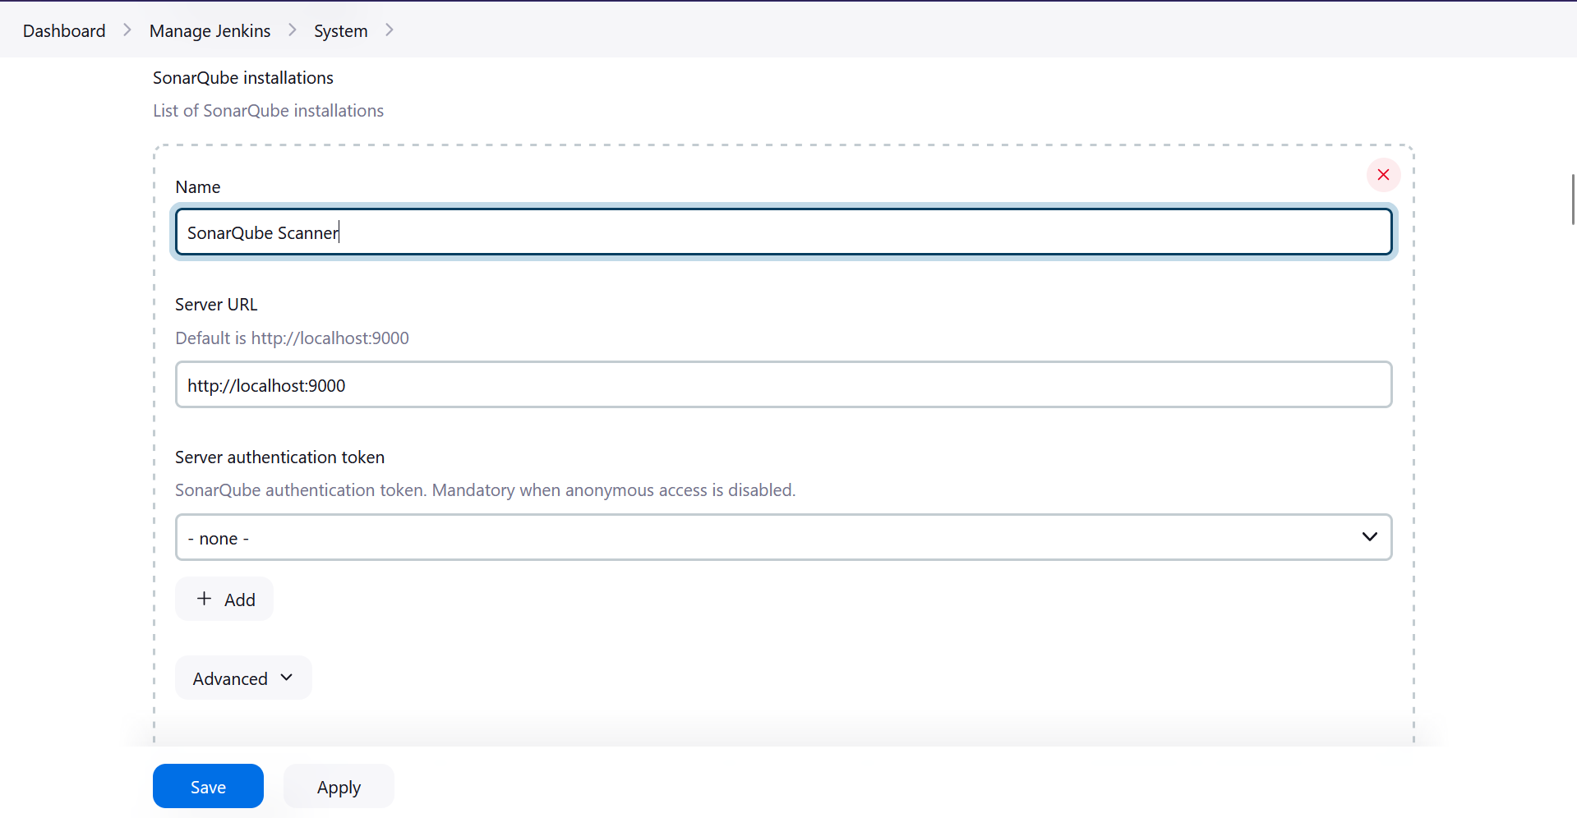

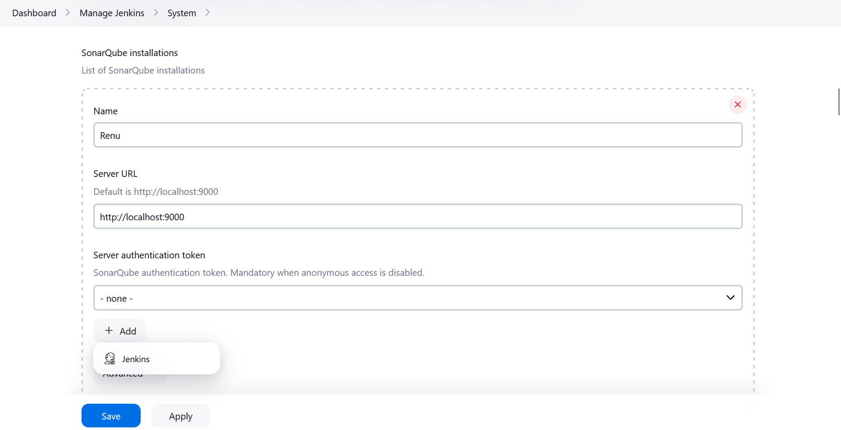

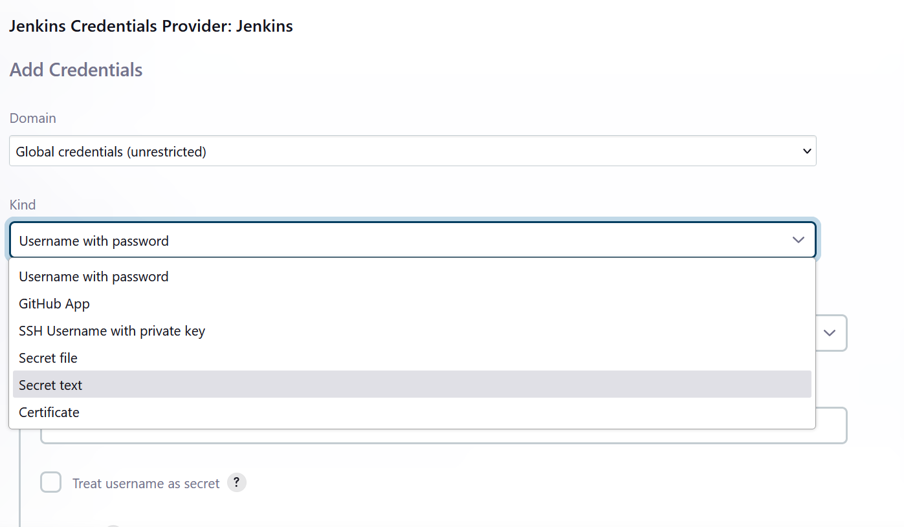

1. Paste the generate access token form Jenkins in Secret field, Put SonarQube-Token in ID and Description SonarQube Token Integration

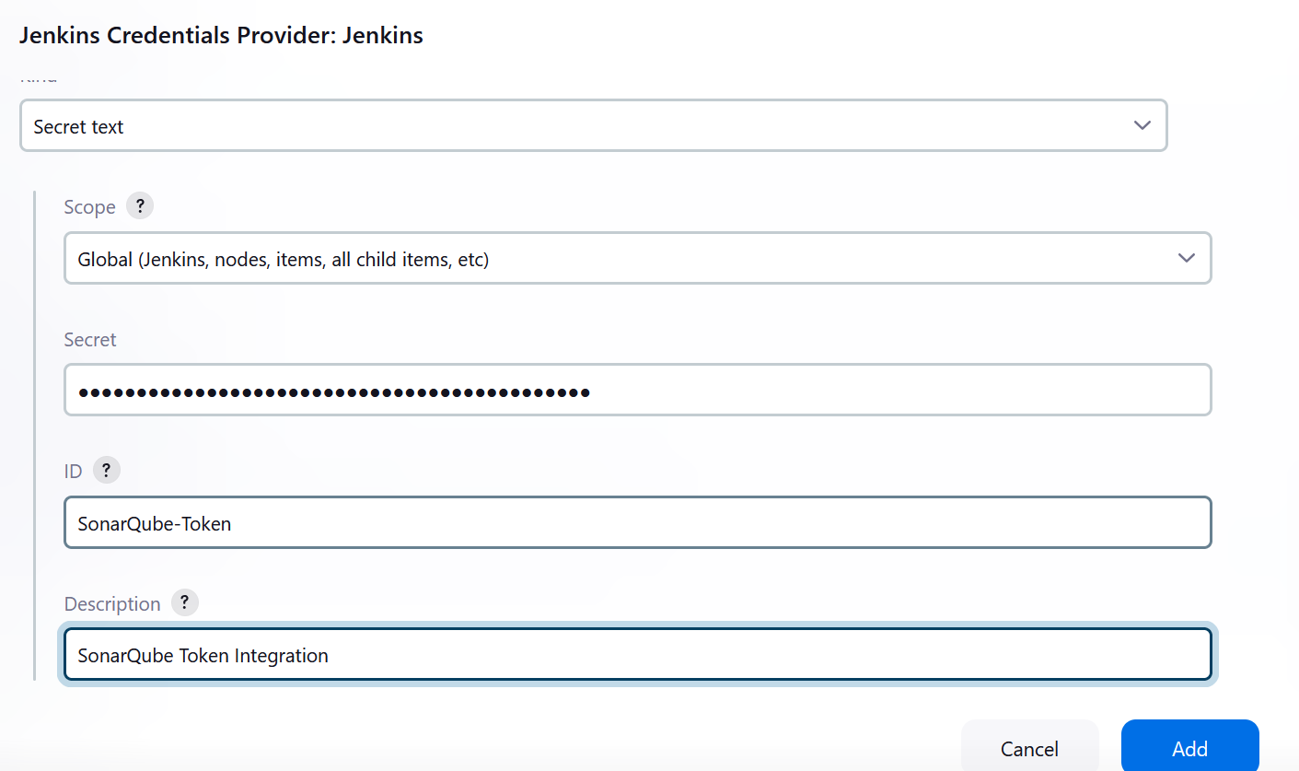

1. Click Add -> You will get a Credentials created msg
2. Select SonarQube Token Integration

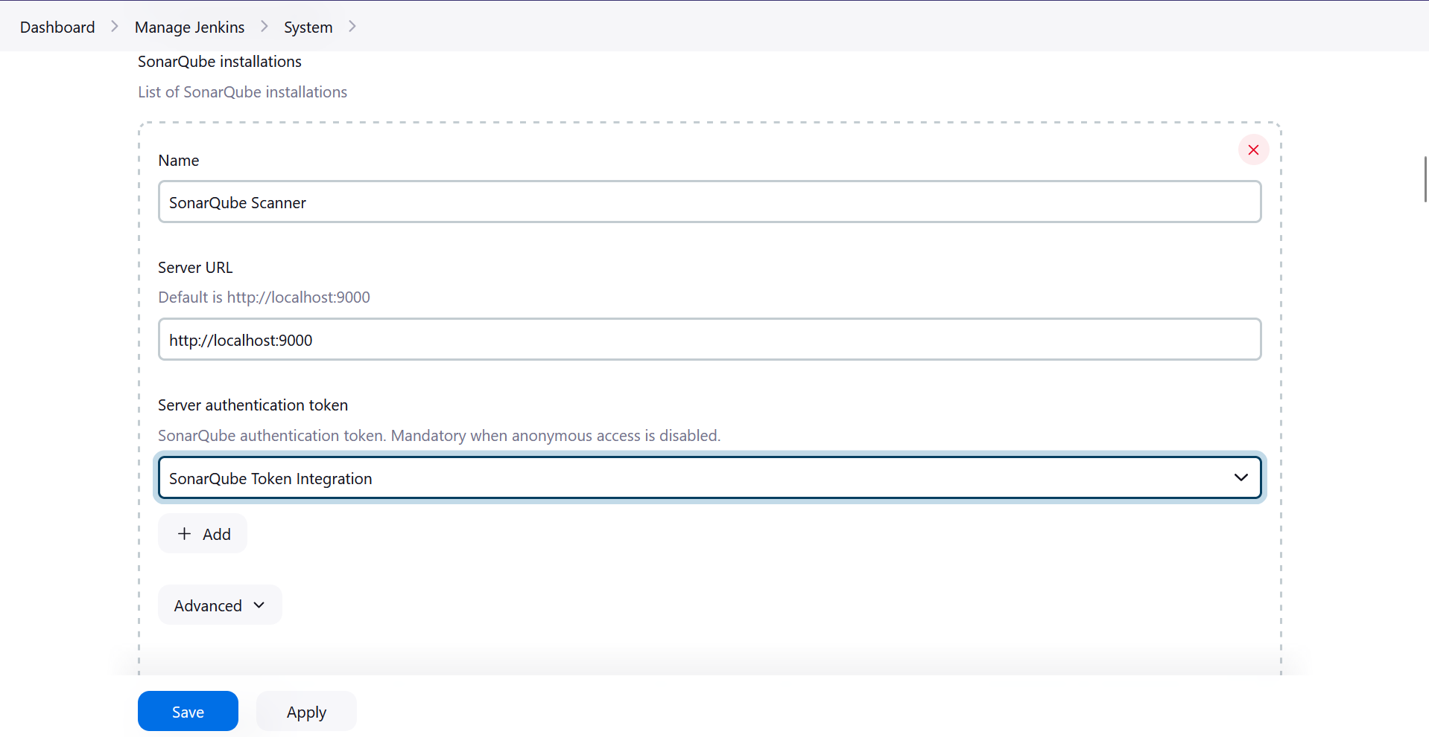

1. Hence, understood Static Analysis SAST process and successfully integrated Jenkins with SonarQube.
2. Running a test app

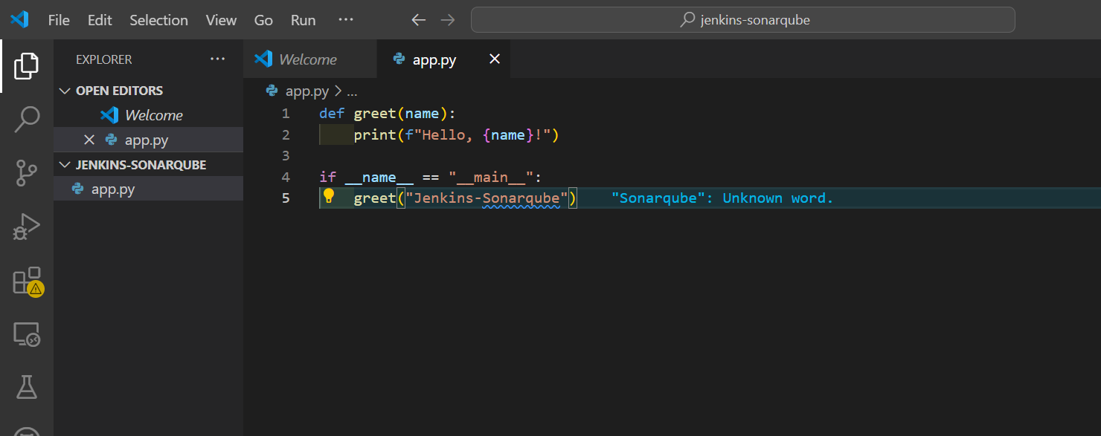

1. On Jenkins Dashboard🡪New Item🡪Give name=app🡪 pipeline project🡪we are now cheking the connection between sonarCube scanner and jenkins

1. On Left select:

pipeline {

agent any

environment {

SCANNER_HOME = tool 'SonarQube Scanner' // Ensure this matches the name of your SonarScanner installation in Jenkins

}

stages {

stage('Build') {

steps {

echo 'Building the Python project...'

bat 'C:\\Users\\acer\\Downloads\\jenkins-sonarqube\\app.py'

// Use bat for Windows commands

}

}

stage('SonarQube Analysis') {

steps {

withSonarQubeEnv('SonarQube') { // 'SonarQube' is the name you configured for your server

bat "${SCANNER_HOME}\\bin\\sonar-scanner.bat -Dsonar.projectKey=my-local-python-project -Dsonar.sources=C:\\jenkins-local-python"

}

}

}

stage('Quality Gate') {

steps {

timeout(time: 1, unit: 'MINUTES') {

waitForQualityGate abortPipeline: true

}

}

}

}

post {

always {

echo 'Pipeline completed'

}

}

}

2. From SonarCube🡪Projects🡪Create Project🡪Local Project

3. Give Project Name🡪 Project code generated automatically

4. Select Global setting

5. Select with Jenkins

Downloading SonarCloud cli On Linux:

